Graded Project

Power BI

Week 6

Table of Content

FIFA Player Data 3

Business Context 3

1. Prepare a rank ordered list of top 10 countries with most players. Which countries are producing the most numbers of footballers that plays at this level? 3

2. Plot the distribution of overall rating vs. age of players. Interpret what is the age after which a players stops improving? 4

3. Which type of offensive players tends to get paid the most: the striker, the right-winger, or the left-winger? Visualize through a scatter plot 4

4. Top 5 players for every preferred position in terms of overall as well as potential points. Who were the best in 2018? Who were destined to be the future superstars in that year? 6

5. Which club(s) have the maximum share of players from England? Which club(s) have the maximum share of players from Spain? Which club(s) have the maximum share of players from Germany? 13

6. Are the wages of a player influenced by the potential of a player? Check it out for players with age Between 16 to 28? 14

7. Do Strikers score higher on "Aggression" than defenders do? Group both the set of players (from an overall score of 80 to 85) and compare their average aggression levels. Which particular position has the highest aggression as a given (players with an overall score of 80 to 90)? 15

8. How based on the positional data, players are profiled for different roles/classes. Plot Aggression, Acceleration, Agility, Balance and Ball Control for strikers and Goal Keepers in a single line/Bar plot to understand the positional difference 17

9. Which clubs consists of the best future players? Consider only the players with Overall < 86 and Potential >=86, plot a graph to show which are the top 10 clubs with most number of best future player 18

# FIFA Player Data

# Business Context

In this project, we will be looking at the player data provided by FIFA which contains information such as personal details, wages, physical attributes, technical skills, potential and their positional strengths. This is primarily data of FIFA 2018.Through this project, you will get a glimpse of insights behind the beautiful game and the kind of information and decisions a football manager goes through. Explore the data and attempt all the below asked questions in a step by step manner

## Prepare a rank ordered list of top 10 countries with most players. Which countries are producing the most numbers of footballers that plays at this level?

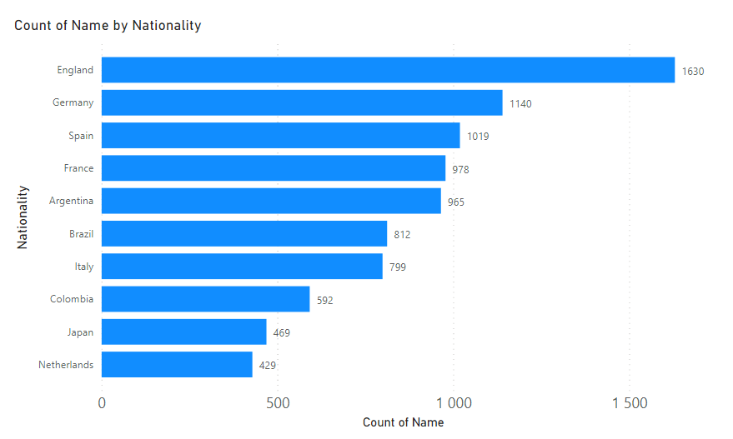

* England is producing the greatest number of players at this level
* From the above table, we see that England produces 1630 footballers this is being followed by Germany and Spain.

## Plot the distribution of overall rating vs. age of players. Interpret what is the age after which a players stops improving?

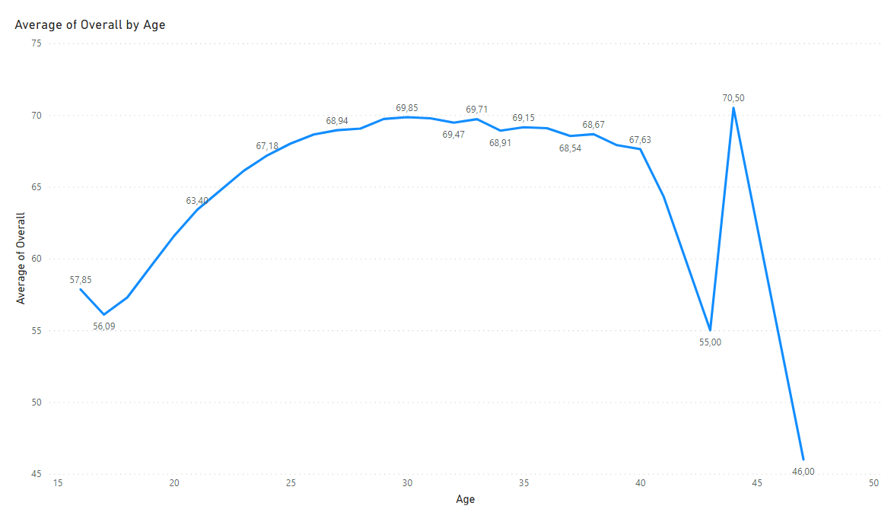

* According to the distribution of overall rating vs. age of players, a player stops improving at an age after 44 with an average overall of 70,5
* Up to 30, players are improving their overall score and most of them have achieved the peak. However, it is observed that players around 42 are making significant leap in advance of overall score.

## Which type of offensive players tends to get paid the most: the striker, the right-winger, or the left-winger? Visualize through a scatter plot

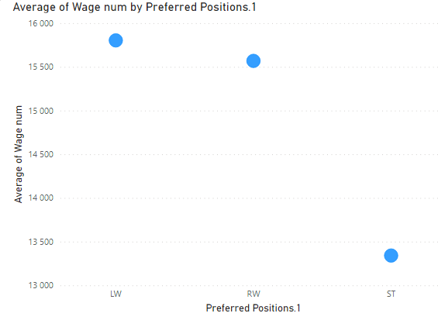

* On an average, the left-winger and the right-wigner are paid the most, around 15k. However, the striker gets only 13k on average.

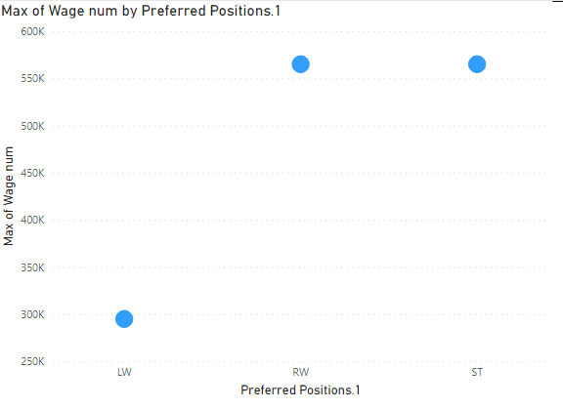

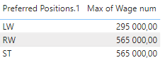

* The maximum wage of right-wigner and striker is equal to 565k, but striker is paid only 295k.

## Top 5 players for every preferred position in terms of overall as well as potential points. Who were the best in 2018? Who were destined to be the future superstars in that year?

Top 5 players for every preferred position in terms of overall

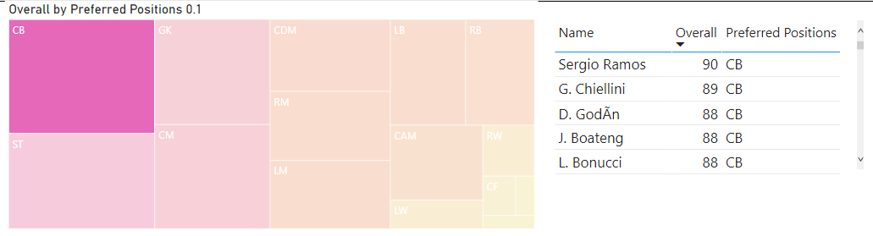

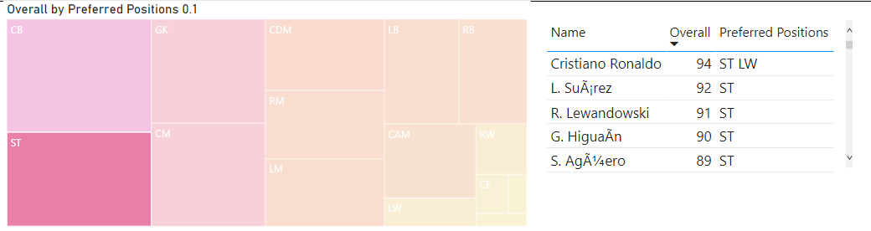

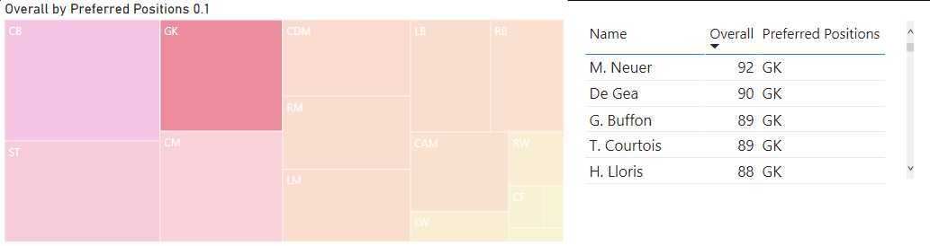

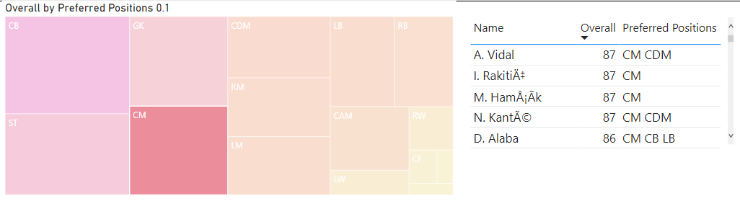

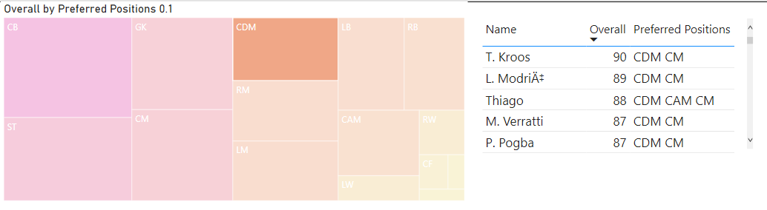

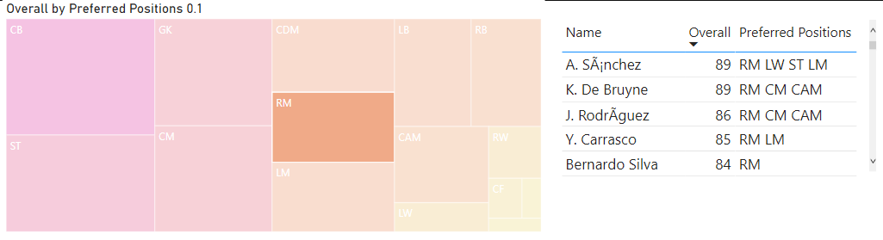

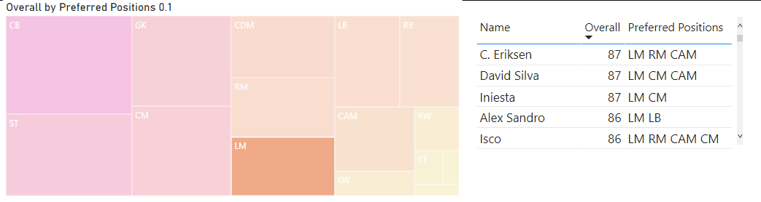

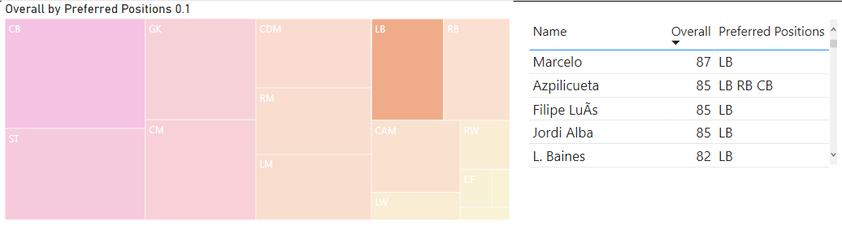

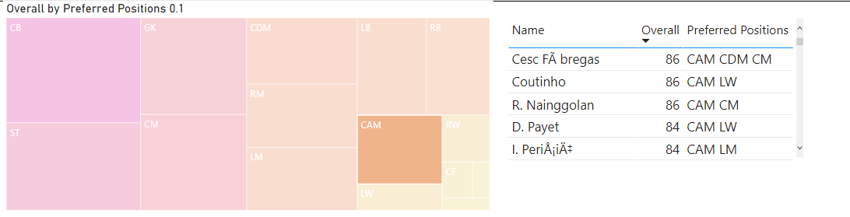

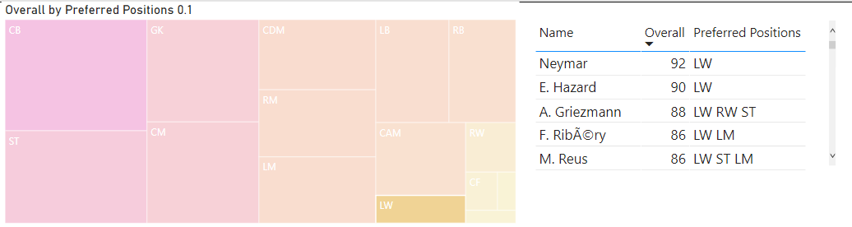

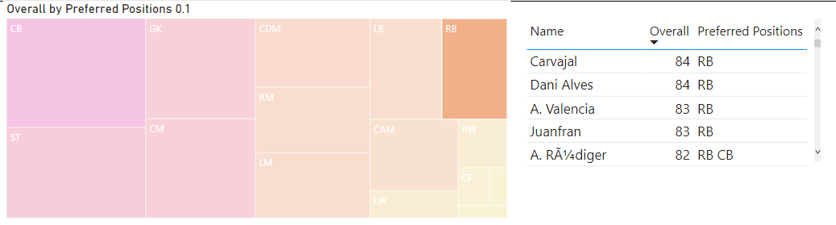

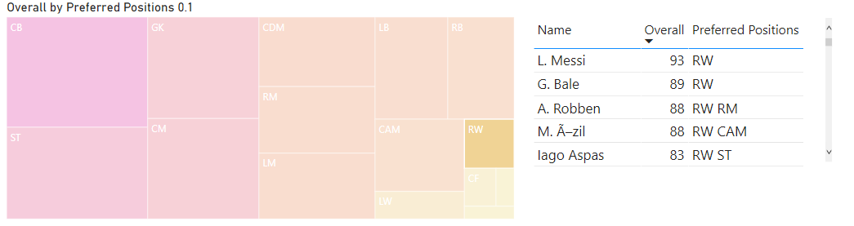

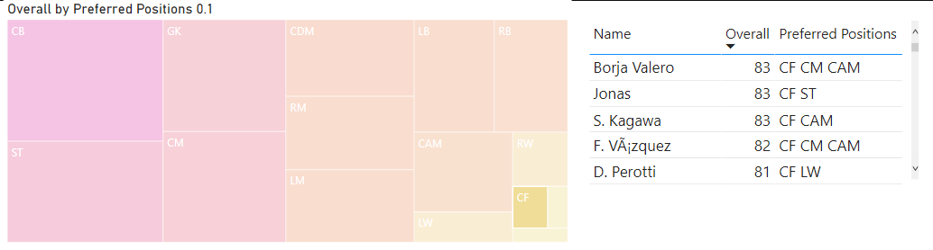

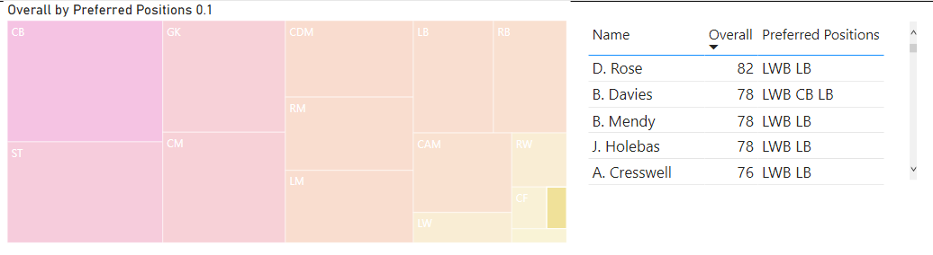

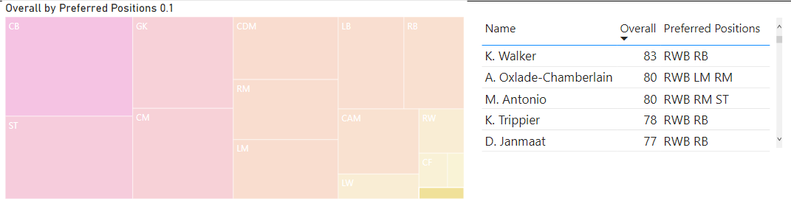

Top 5 players for every preferred position in terms of potential

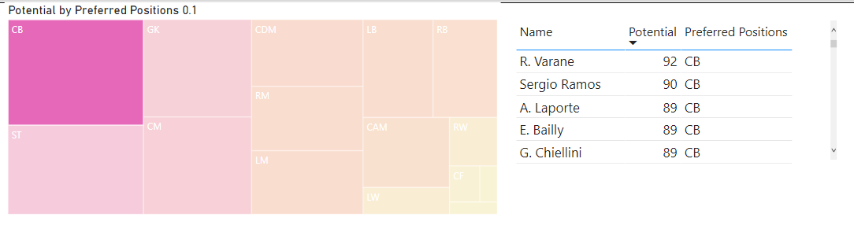

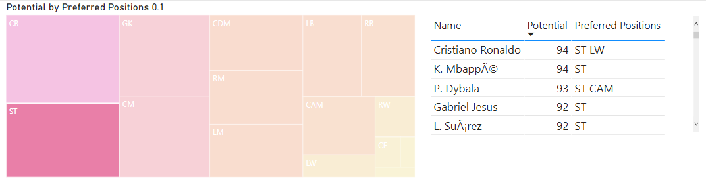

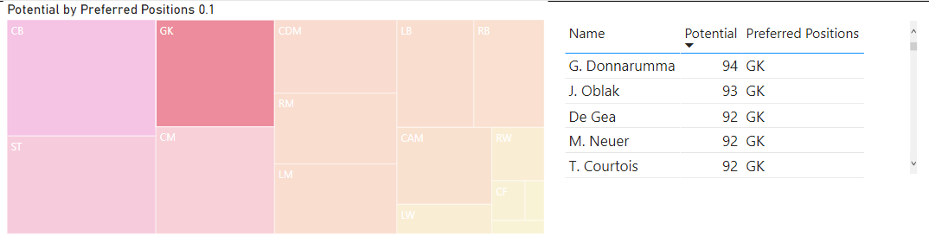

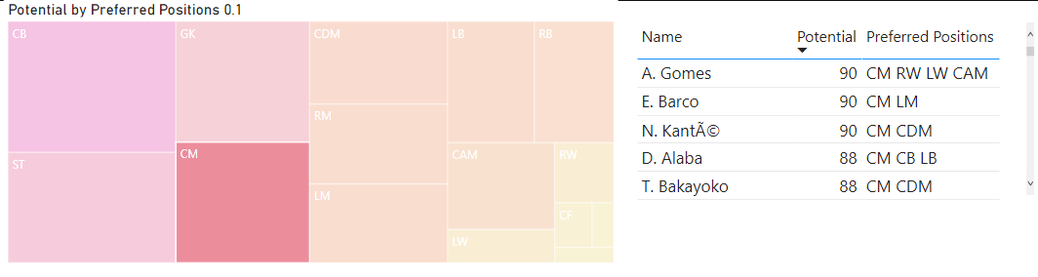

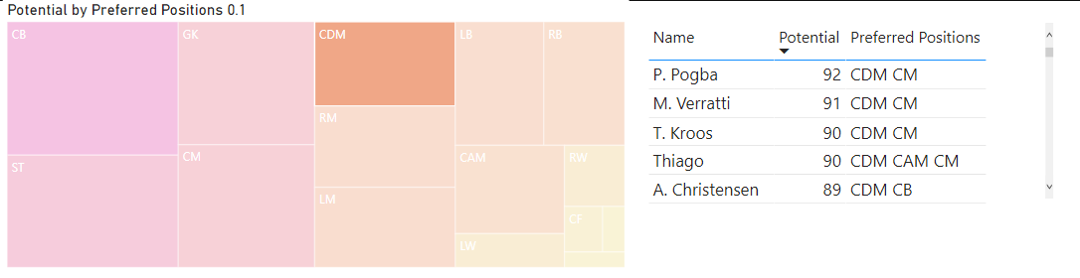

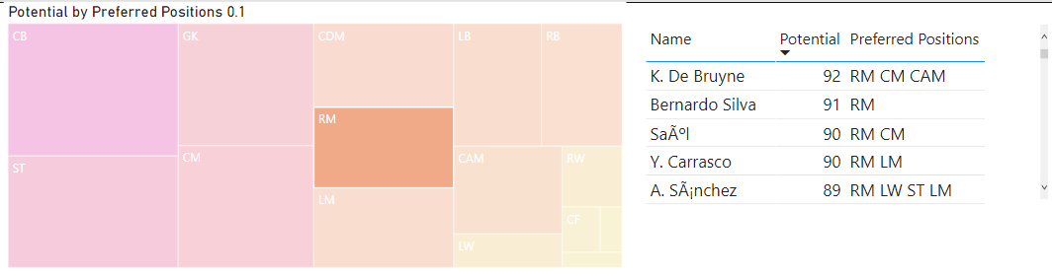

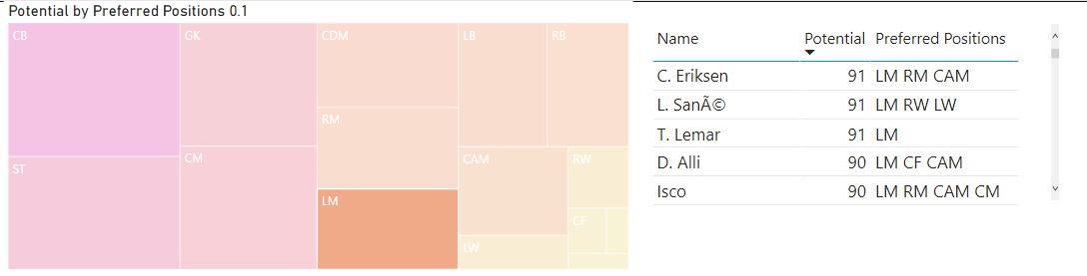

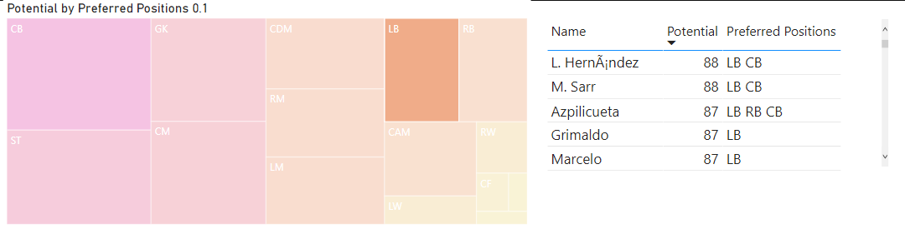

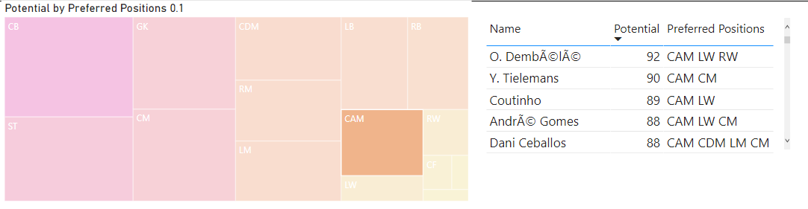

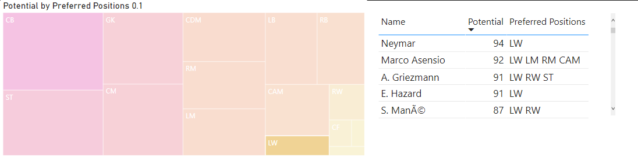

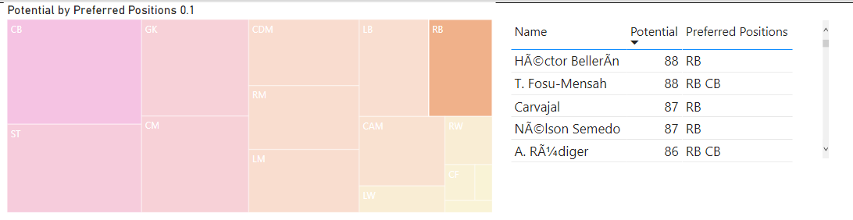

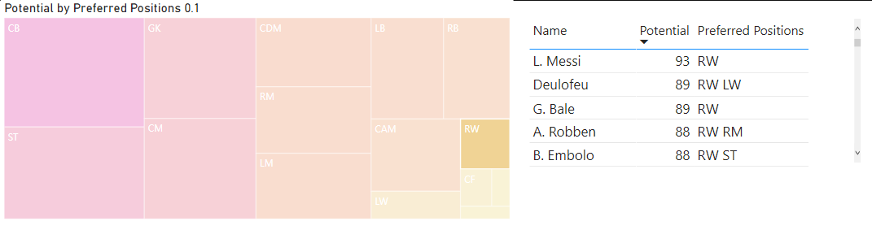

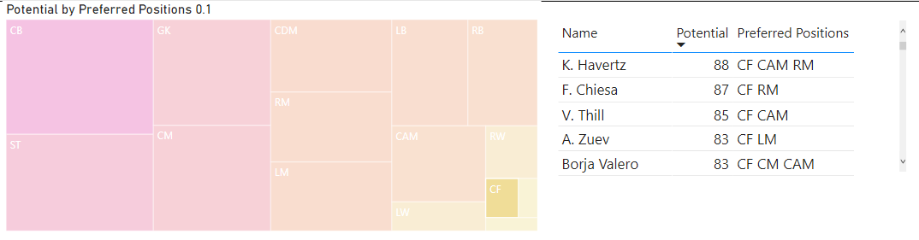

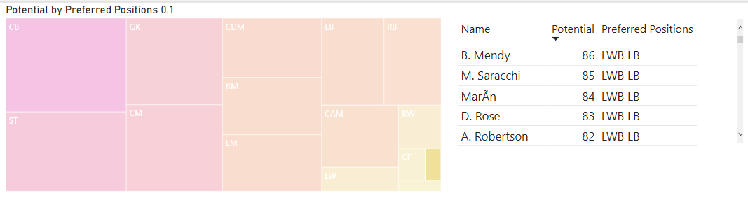

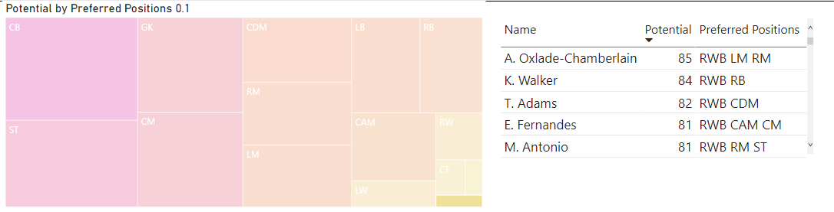

The following players were the best in 2018:

Following players were destined to be the future superstars in that year:

* Christiano Ronaldo, L. Messi, Neymar, De Gea are considered one of the best players in 2018 and they are also having a great chance to be the future superstars

## Which club(s) have the maximum share of players from England? Which club(s) have the maximum share of players from Spain? Which club(s) have the maximum share of players from Germany?

* The above plot shows the clubs in which most shares of the players are from England. The clubs such as Bolton Wanderers, Shrewsbury contains maximum share of players from England. These are followed by Burton Albions, Chesterfield, Mansfield and Portsmouth club.

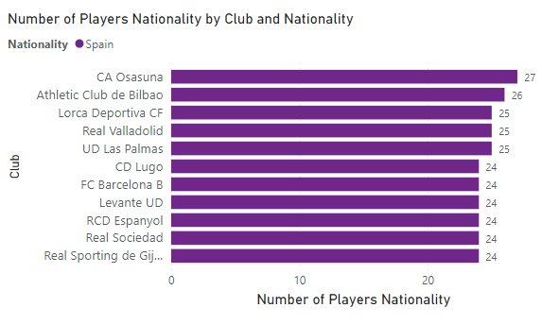

* The above plot shows the clubs in which most shares of the players are from Spain. The club CA Osasuna contains maximum share of players from Spain. These are followed by Athletic Club de Bilbao and Lorca Deportivo CF club.

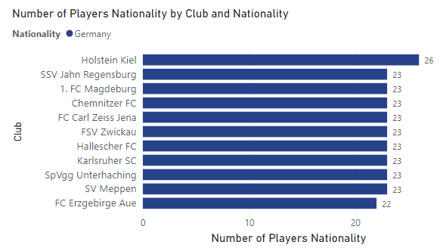

* The above plot shows the clubs in which most shares of the players are from Germany. The club Holstein Kiel contains maximum share of players from Germany. These are followed by SSV Jahn Regensburg club and FC Magdeburg club.

## Are the wages of a player influenced by the potential of a player? Check it out for players with age Between 16 to 28?

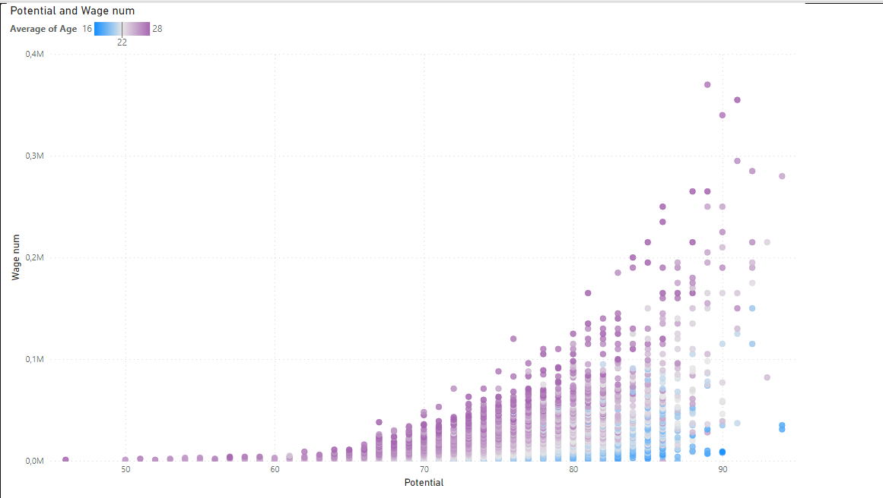

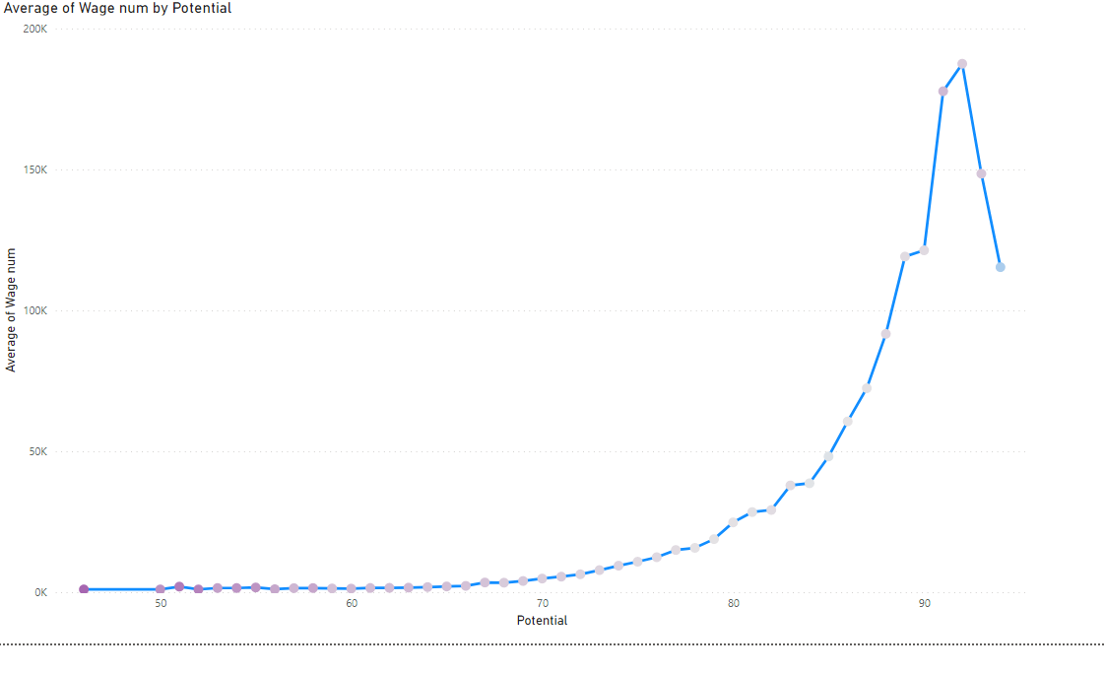

* The general pattern reveals that more the potential a player has, he is likely to have higher the wage.
* We have used a scatter plot and line plot to come to the conclusion. The presence of outliers or exceptions has caused the Average Wage Vs Potential line graph to have a sudden dip towards the end, otherwise, an exponentially increasing trend can be observed.

## Do Strikers score higher on "Aggression" than defenders do? Group both the set of players (from an overall score of 80 to 85) and compare their average aggression levels. Which particular position has the highest aggression as a given (players with an overall score of 80 to 90)?

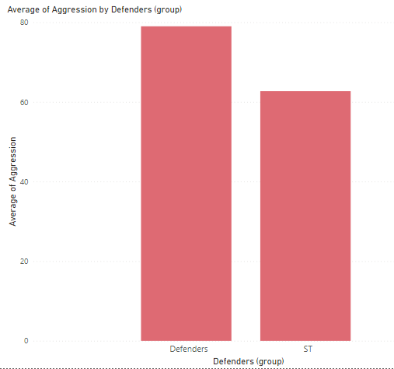

* It can be observed from the bar graph that the average aggression score of Strikers (ST) is much lower than that of the Defenders (CB, LB, RB, RWB, LWB) for the players with an overall score in the 80-85 bracket

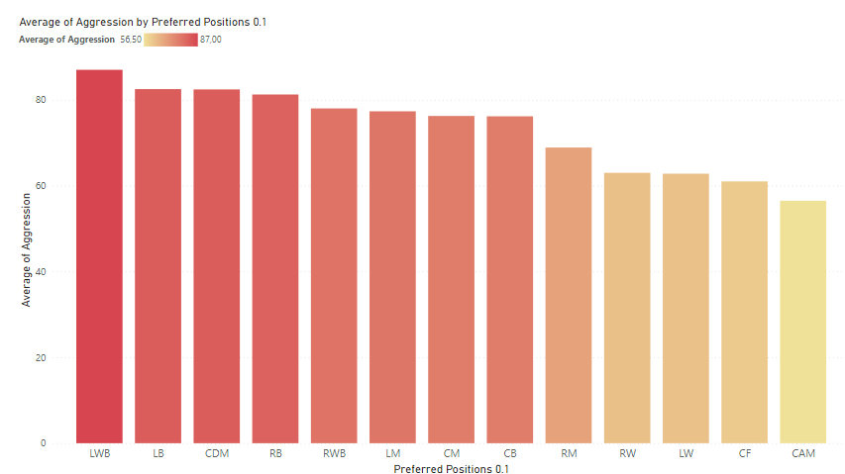

* Players with an overall of 80-90 and in the LWB (Left Wing Back) position rank the highest in terms of average aggression score

## How based on the positional data, players are profiled for different roles/classes. Plot Aggression, Acceleration, Agility, Balance and Ball Control for strikers and Goal Keepers in a single line/Bar plot to understand the positional difference

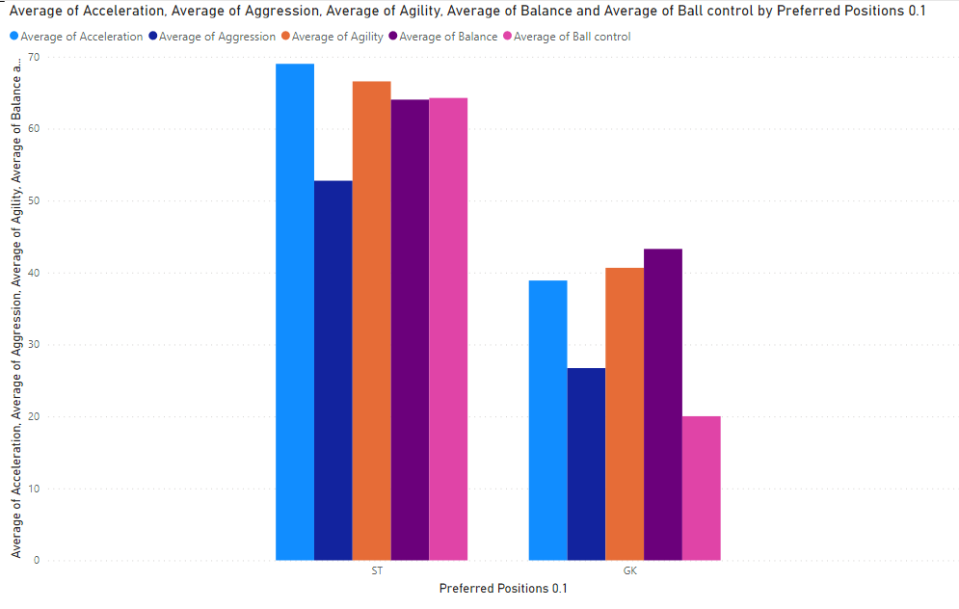

* Based on the positional data, the players are profiled for different roles/classes. The Aggression, Acceleration, Agility, Balance and Ball Control are plotted for strikers and Goal Keepers in a single Bar plot to understand the positional difference
* It can be inferred with the help of the visualization above that the average score of Goalkeepers in terms of Aggression, Acceleration, Agility, Balance and Ball Control is lesser than that of the Strikers.
* The most contrasting difference can be observed for the average score of ball control for Strikers and Goalkeepers.

## Which clubs consists of the best future players? Consider only the players with Overall < 86 and Potential >=86, plot a graph to show which are the top 10 clubs with most number of best future player

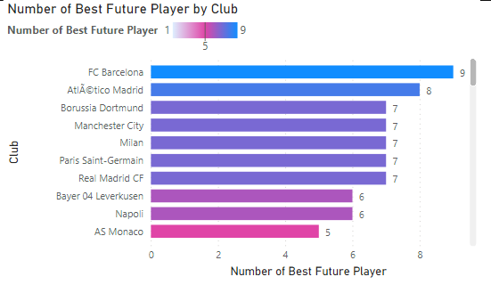

* By considering only the players with Overall <85 and Potential >=86, the plot above shows the top 10 clubs with the greatest number of best future players
* We can see from the graph and the table present on this page that FC Barcelona has the maximum number of best future players followed by Atlético Madrid. Borussia Dortmund, Machester City, Milan, Paris Saint-German and Real Madrid CF all lie in the third position with an equal number of best future players.